Affordable Housing Subgroup of Housing and Homelessness Stakeholders Group
Notes on 2018 Lawrence Housing Market Analysis
- Demographic Profile
  - Population in 2017 – 96,892
    - Population from 2020 census -- ~94,934
    - Average growth rate of 1.5%
  - 80% (20,000) of KU student population lives off campus
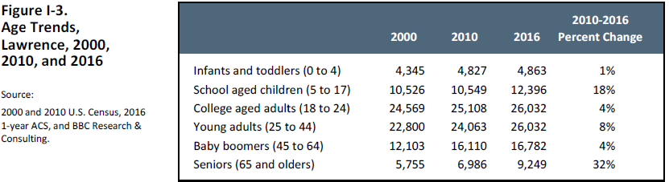
  - Large share of Lawrence residents ages 20-24 leave Lawrence
  - Center for Economic Development and Business Research provides projections, projecting average annual growth rate of 1.2% until 2064
  - Senior population grew the most with school aged children behind them.
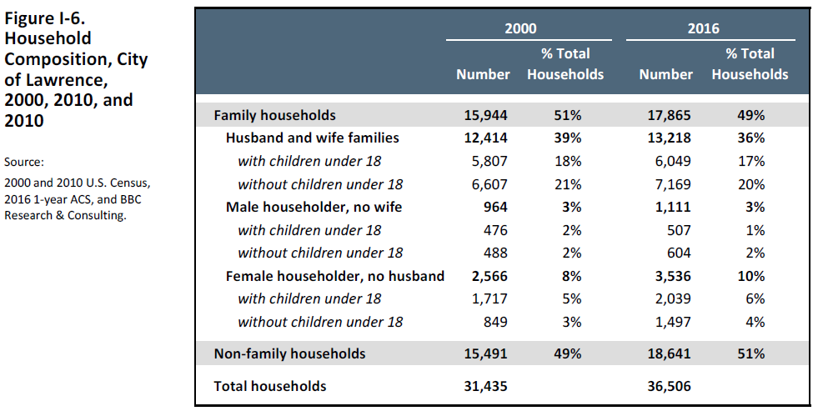
- Population of single and family households are pretty 50/50 in the community.
- Housing Profile and Market Analysis
  - Most homes in Lawrence are good-sized. The median number of rooms per housing unit in Lawrence is 5.2, According to the Census. Nearly 40 percent of housing units have 3 BRs; most common size of unit. 20% of units have 4 and 5 bedrooms; 14% are 1 bedroom units; and 25% are 2 bedroom units. Only 2% are studios.
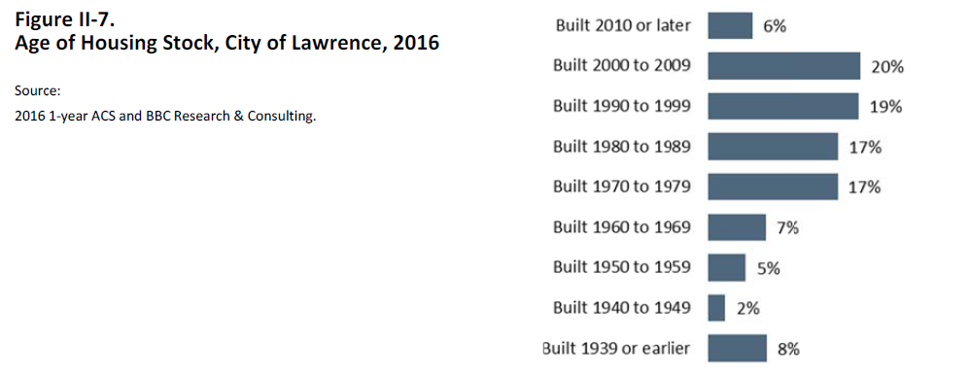
Shows an obvious need for funding to develop property.
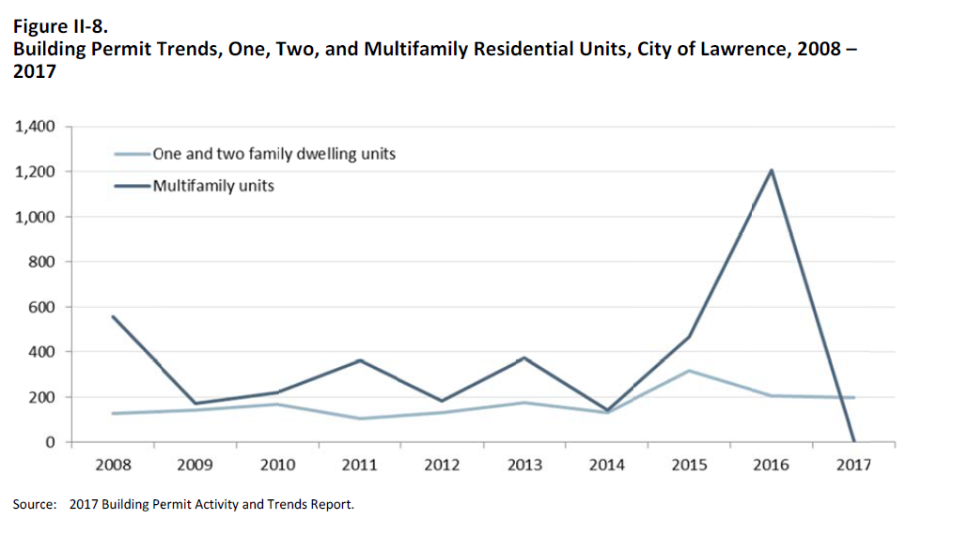
Multifamily development plummeted around 2017 -- wondering if this holds true into 2022.
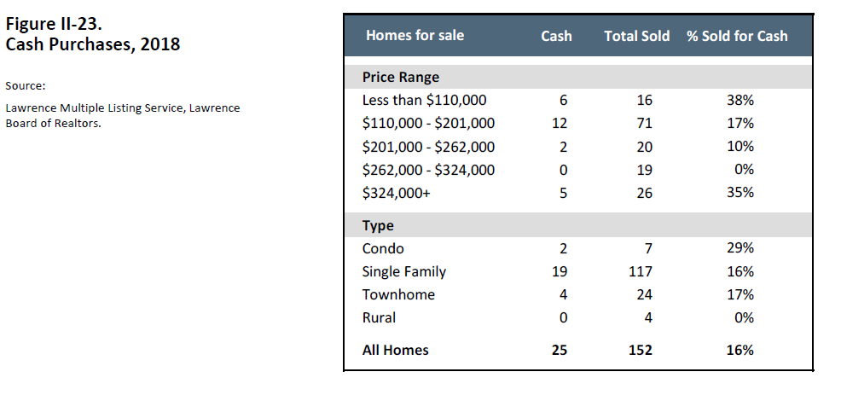
Cash purchases have gone up, which an assumption can be made that this will decrease affordable units available for purchase by making these rentals.
  - There are 211 extremely low income renters who would like to buy a home and have no inventory to purchase.
  - Another 512 very low income renters would also like to buy. These renters have only 34
  - homes from which to choose. Both these and the 211 extremely low income renters are unlikely to become owners except through sweat equity or land trust programs that target very low income households.
  - In sum, if every renter who wanted to buy was qualified to buy, the Lawrence market would need to add 1,681 homes for sale to accommodate demand.
  - Altogether, the city has a shortage of 5,272 rental units priced affordably for renters earning less than $20,000 per year (assuming 30% of income)
  - The 2,800 non‐student households with affordability needs that are reflected in the rental gaps are largely:
    - Residents who need publicly subsidized housing and earn about $15,000/year on average. These residents can afford to pay $500 per month in rent and utilities—rents which the private sector cannot provide.
    - Female heads of household (70%); seniors (38%); residents with disabilities (30%); and
    - single mothers (25%).
- Community Input
  - One in four Lawrence residents with disabilities (24%) live in housing that does not meet their accessibility needs. Among the residents whose homes need accessibility modifications, two in three need a ramp, half need grab bars in bathrooms, and half need wider doorways.

  - Repair needs.
    - Overall, 41 percent of Lawrence residents with homes in fair or poor condition need repairs to improve their home’s condition. When asked to identify the most important repair needed for their home, the greatest proportion of respondents identified:
      - Weatherization (26%);
      - Roof (8%);
      - Heating/cooling (8%); and
      - Bathroom plumbing (8%).
    - When asked why repairs weren’t made, 75% of homeowners can’t afford, 57% of renters have landlords who refuse or have yet to make needed repairs despite requests.
  - 1 in 4 Lawrence residents with disabilities (24%) live in housing that does not meet their accessibility needs.
  - Renters with children and non-student renters were most likely to experience displacement in the past three years.
  - “non-white” Lawrence residents who responded to the survey are less likely to be homeowners (44% compared to 68% of white respondents)
  - Report makes note that residents who have felony drug charges and persons in recovery are particularly vulnerable in tight rental markets. Families with parents in recovery need stable, affordable housing to support their recovery. The City’s new housing fund would be ideal for addressing this gap in need and funding.
  - Half (52%) of landlords rent available units in less than 1 week.
  - Properties into multiple units in the past needing to conform to current zoning reduces stock of much needed rentals.
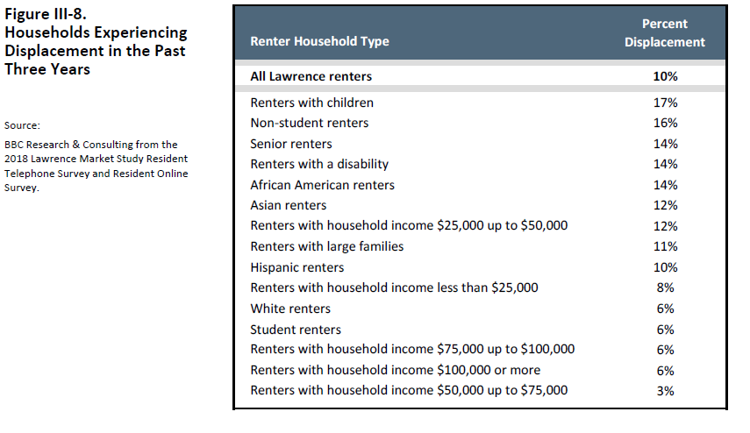

Findings and Recommendations
  - Findings
    - The city’s growth between 2010 and 2020 is likely to replicate 1990 to 2000 in numbers.
    - The city will have gained 14,000 residents by 2020.
    - Renters who cannot afford their current rentals and are cost-burdened
      - 5,200
    - Renters who want to buy and could be candidates for ownership
      - 2,000
    - Families experiencing homelessness/at-risk of homelessness
      - 700
    - Households with disabilities with accessibility modification needs
      - 500
    - Renters with units in poor or fair condition
      - 2,950
    - Owners with units in poor or fair condition
      - 500
  - Recommendations
    - Short term (2020-2023)
      - 100 new affordable units
        - Determine available land and property
        - Examine the sites for potential residential development
        - Acquire land/property
        - Issue an RFP to nonprofit or private partners
      - 150 more units are affordable to low and moderate income renters who are qualified to become owners priced between $100,000 and $260,000
        - 50-100% Median Family Income (MFI)
          - $61,020 is median family income
          - 50-100% is between $30,510-$61,020
      - 25 rental households assisted with accessibility modifications (benchmark is 11 annually)
        - Increase number of rental households with disabilities who receive grants from the city for accessibility improvements
          - What are grants from the city for accessibility improvements?
        - Consider enhancing this program to provide additional rehabilitation and weatherization to private property owners who agree to keep units affordable for a period of time (10-15 years, depending on amount of grant)
        - Engage private sector developers in a discussion about incentives to increase viability in housing and consider implementing solutions
      - 25 more vouchers available
        - Increase tenant based rental assistance to supplement section 8 program; buy down units in $625/$875 range.
        - Consider creating an incentive fund for property owners who agree to rent to voucher holders. This fund could cover the costs of damage, wear and tear, and weatherization improvements.
      - 70 number of homes and apartments brought into good condition (benchmark is 35 annually)
        - Increase funding for home modifications and weatherization. Fund with housing trust funds to increase grant effectiveness and overall funding by removing regulatory inefficiencies; Supplement with incentive programs proposed above.
        - Evaluate the City's current rental inspection sampling program, using guidance from the survey data in the Housing Needs Assessment, to ensure that the City's process has the ability to detect condition problems reported by residents. Evaluate if energy codes and programs are adding unnecessary costs to housing payments.
    - Long term (2024-2028)
      - 500 new affordable rental units
      - 200 more units are affordable to low and moderate income renters who are qualified to become homeowners
      - 25 annual rental households that receive accessibility modifications (benchmark is 11 annually)
      - 50 more vouchers available
      - 70 number of homes and apartments brought into good condition (benchmark is 35 annually)

